DAY-6
1.Write a program to implement Circular Queue with insertion and deletion operations.
#include <stdio.h>
#define SIZE 5
int queue[SIZE];
int front = -1, rear = -1;
void enqueue(int value) {
if ((front == 0 && rear == SIZE - 1) || (rear == (front - 1) % (SIZE - 1))) {
printf("Queue is full\n");
} else if (front == -1) {
front = rear = 0;
queue[rear] = value;
} else if (rear == SIZE - 1 && front != 0) {
rear = 0;
queue[rear] = value;
} else {
rear++;
queue[rear] = value;
}
}
int dequeue() {
if (front == -1) {
printf("Queue is empty\n");
return -1;
}
int data = queue[front];
queue[front] = -1;
if (front == rear) {
front = rear = -1;
} else if (front == SIZE - 1) {
front = 0;
} else {
front++;
}
return data;
}
void display() {
if (front == -1) {
printf("Queue is empty\n");
return;
}
printf("Elements in Circular Queue are: ");
if (rear >= front) {
for (int i = front; i <= rear; i++) {
printf("%d ", queue[i]);
}
} else {
for (int i = front; i < SIZE; i++) {
printf("%d ", queue[i]);
}
for (int i = 0; i <= rear; i++) {
printf("%d ", queue[i]);
}
}
printf("\n");
}
int main() {
enqueue(1);
enqueue(2);
enqueue(3);
display();
dequeue();
display();
enqueue(4);
enqueue(5);
enqueue(6);
display();
return 0;
}
OUTPUT:
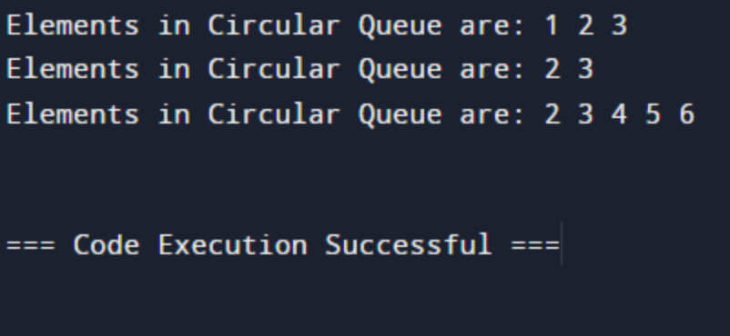
2.Write a program to implement Double Ended Queue with insertion and deletion operations.
#include <stdio.h>
#include <stdlib.h>
typedef struct Node {
int data;
struct Node* next;
struct Node* prev;
} Node;
typedef struct {
Node* front;
Node* rear;
int size;
} Deque;
void initDeque(Deque* dq) {
dq->front = NULL;
dq->rear = NULL;
dq->size = 0;
}
int isEmpty(Deque* dq) {
return dq->size == 0;
}
void addFront(Deque* dq, int element) {
Node* newNode = (Node*)malloc(sizeof(Node));
newNode->data = element;
newNode->next = dq->front;
newNode->prev = NULL;
if (isEmpty(dq)) {
dq->front = newNode;
dq->rear = newNode;
} else {
dq->front->prev = newNode;
dq->front = newNode;
}
dq->size++;
}
void addRear(Deque* dq, int element) {
Node* newNode = (Node*)malloc(sizeof(Node));
newNode->data = element;
newNode->next = NULL;
newNode->prev = dq->rear;
if (isEmpty(dq)) {
dq->front = newNode;
dq->rear = newNode;
} else {
dq->rear->next = newNode;
dq->rear = newNode;
}
dq->size++;
}
int removeFront(Deque* dq) {
if (isEmpty(dq)) {
printf("Deque is empty. Cannot remove from front.\n");
return -1;
}
int element = dq->front->data;
Node* temp = dq->front;
dq->front = dq->front->next;
if (dq->front == NULL) {
dq->rear = NULL;
} else {
dq->front->prev = NULL;
}
free(temp);
dq->size--;
return element;
}
int removeRear(Deque* dq) {
if (isEmpty(dq)) {
printf("Deque is empty. Cannot remove from rear.\n");
return -1;
}
int element = dq->rear->data;
Node* temp = dq->rear;
dq->rear = dq->rear->prev;
if (dq->rear == NULL) {
dq->front = NULL;
} else {
dq->rear->next = NULL;
}
free(temp);
dq->size--;
return element;
}
void printDeque(Deque* dq) {
Node* temp = dq->front;
printf("Deque: ");
while (temp != NULL) {
printf("%d ", temp->data);
temp = temp->next;
}
printf("\n");
}
int main() {
Deque dq;
initDeque(&dq);
printf("Is deque empty? %d\n", isEmpty(&dq));
printf("Deque size: %d\n", dq.size);
addFront(&dq, 10);
addRear(&dq, 20);
addFront(&dq, 5);
addRear(&dq, 30);
printDeque(&dq);
printf("Removed from front: %d\n", removeFront(&dq));
printf("Removed from rear: %d\n", removeRear(&dq));
printDeque(&dq);
addFront(&dq, 15);
addRear(&dq, 40);
printDeque(&dq);
printf("Deque size: %d\n", dq.size);
return 0;
}
OUTPUT:
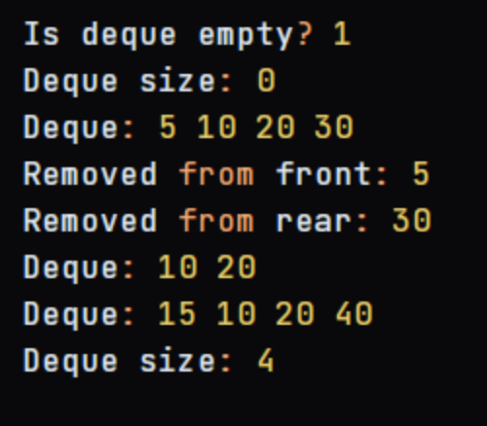
3.Write a program to implement Priority Queue with insertion and deletion operations.
#include <stdio.h>
#include <stdlib.h>
typedef struct Node {
int data;
int priority;
struct Node* next;
} Node;
typedef struct {
Node* front;
Node* rear;
int size;
} PriorityQueue;
void initPriorityQueue(PriorityQueue* pq) {
pq->front = NULL;
pq->rear = NULL;
pq->size = 0;
}
int isEmpty(PriorityQueue* pq) {
return pq->size == 0;
}
void enqueue(PriorityQueue* pq, int data, int priority) {
Node* newNode = (Node*)malloc(sizeof(Node));
newNode->data = data;
newNode->priority = priority;
newNode->next = NULL;
if (isEmpty(pq)) {
pq->front = newNode;
pq->rear = newNode;
} else {
Node* temp = pq->front;
while (temp->next != NULL && temp->next->priority > priority) {
temp = temp->next;
}
newNode->next = temp->next;
temp->next = newNode;
}
pq->size++;
}
int dequeue(PriorityQueue* pq) {
if (isEmpty(pq)) {
printf("Priority Queue is empty. Cannot dequeue.\n");
return -1;
}
int data = pq->front->data;
Node* temp = pq->front;
pq->front = pq->front->next;
if (pq->front == NULL) {
pq->rear = NULL;
}
free(temp);
pq->size--;
return data;
}
void printPriorityQueue(PriorityQueue* pq) {
Node* temp = pq->front;
printf("Priority Queue: ");
while (temp != NULL) {
printf("(%d, %d) ", temp->data, temp->priority);
temp = temp->next;
}
printf("\n");
}
int main() {
PriorityQueue pq;
initPriorityQueue(&pq);
printf("Is priority queue empty? %d\n", isEmpty(&pq));
printf("Priority Queue size: %d\n", pq.size);
enqueue(&pq, 10, 3);
enqueue(&pq, 20, 1);
enqueue(&pq, 30, 2);
enqueue(&pq, 40, 4);
printPriorityQueue(&pq);
printf("Dequeued: %d\n", dequeue(&pq));
printPriorityQueue(&pq);
enqueue(&pq, 50, 5);
enqueue(&pq, 60, 2);
printPriorityQueue(&pq);
printf("Priority Queue size: %d\n", pq.size);
return 0;
}
OUTPUT:
